### Assignment 1:

Demonstrate minimum 15 basic docker command with explanation and screenshot.

1. **docker ps**

show the list of all running containers.

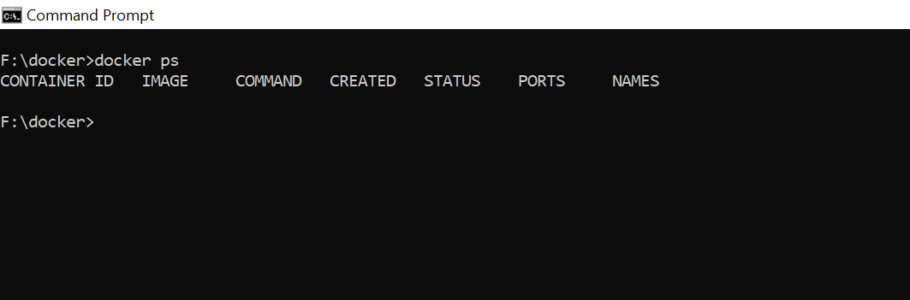

1. **docker ps -a**

shows the list of all containers with their names, images, status and their creation timings.

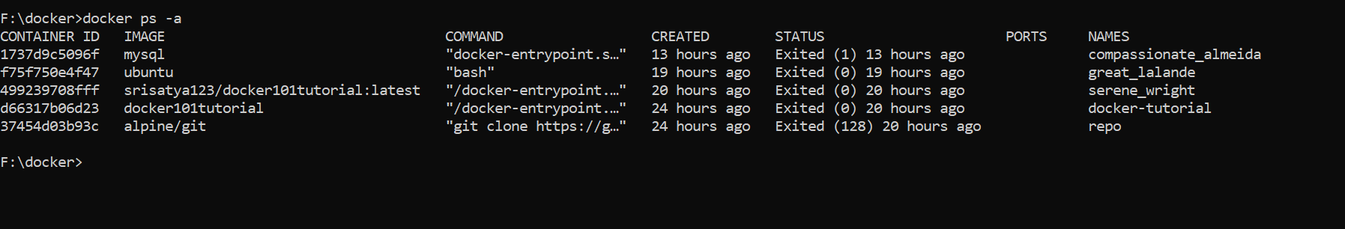

1. **docker – -version**

displays the installed docker version

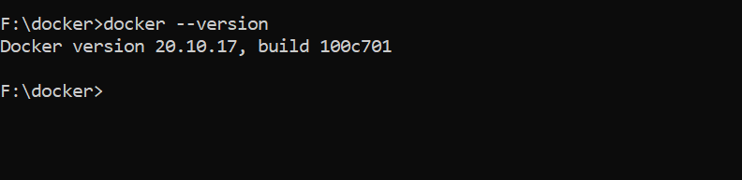

1. **docker images**

shows the images are available in the docker locally.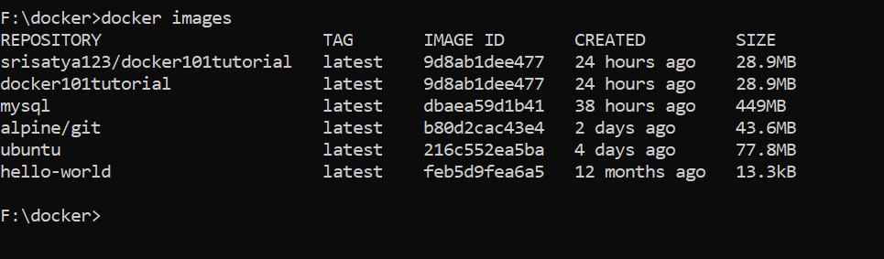

1. **docker pull <image name>**

this is used to pull the decker images from the docker hub.

docker pull hello-world 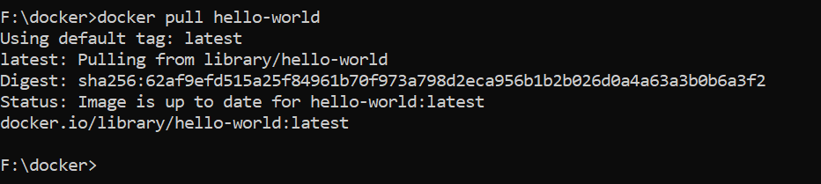

1. **docker run <image name>**

docker run hello-world

This command is used to run the image and it creates contrainer.

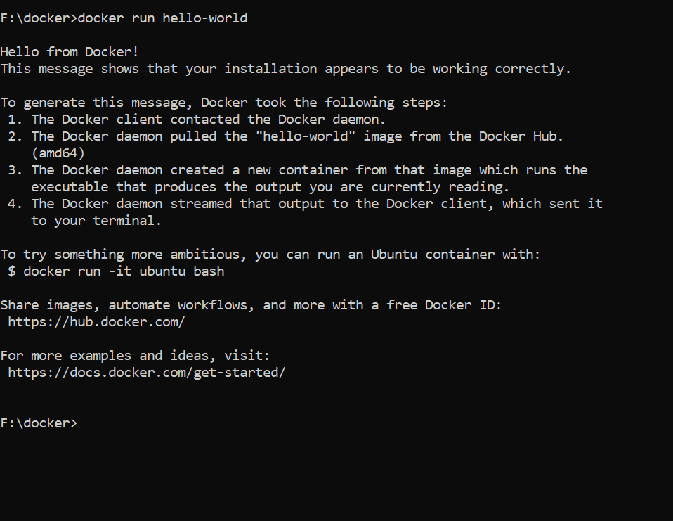

1. **docker stop <container id>**

This command stops a running container

docker stop ce20d5b2395e

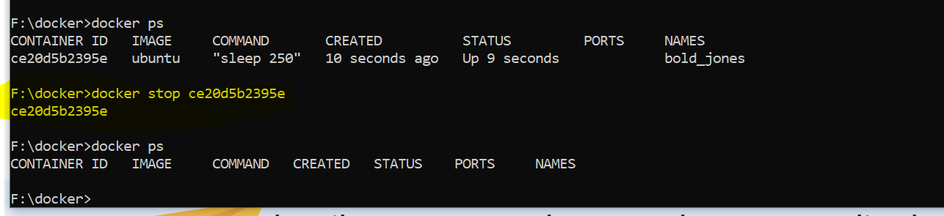

1. **docker kill <container id>**

This commands kills the container by stopping its execution abruptly and it don’t wait for the container to shutdown smoothly.

1. **docker commit <conatainer id> <username/imagename>**

this is used to create new image from the existing container on the local system.

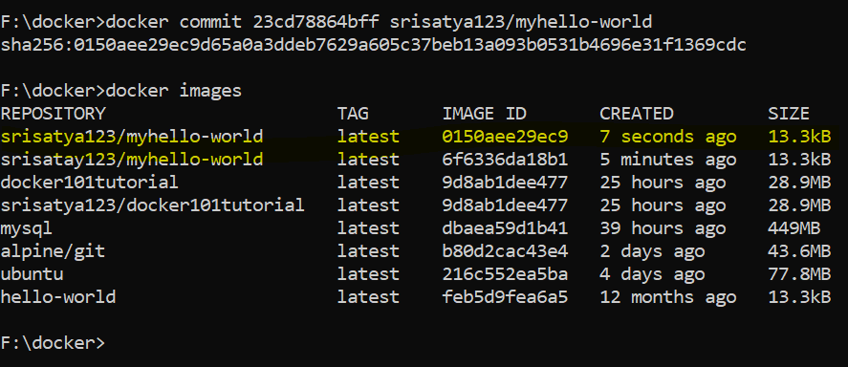

1. **docker login**

This command is used to login the docker hub repository.

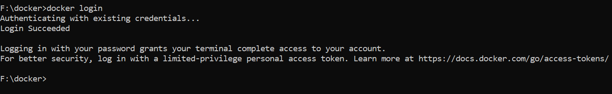

1. **docker push <username/image name>**

docker push srisatya123/myhello-world

This command is used to push the image to the docker hub repository.

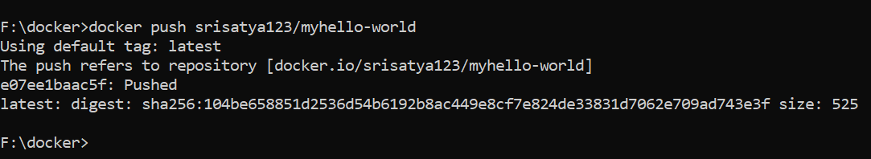

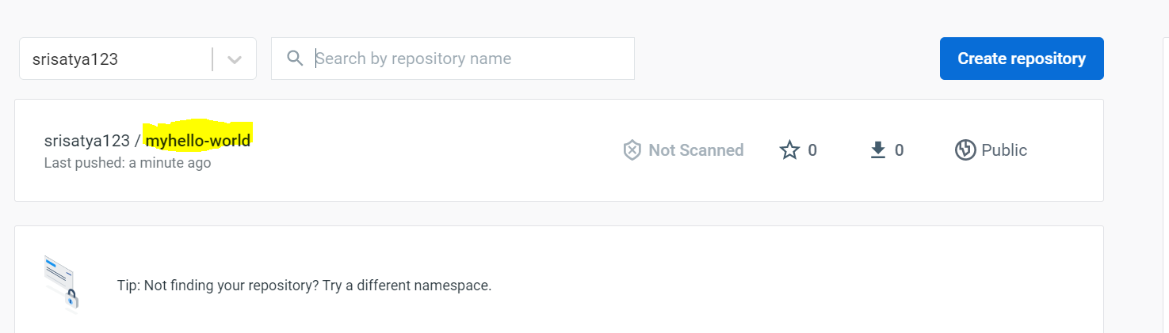

1. **docker rm** **<container id>**

docker rm 23cd78864bff

This command removes the container of the given container id.

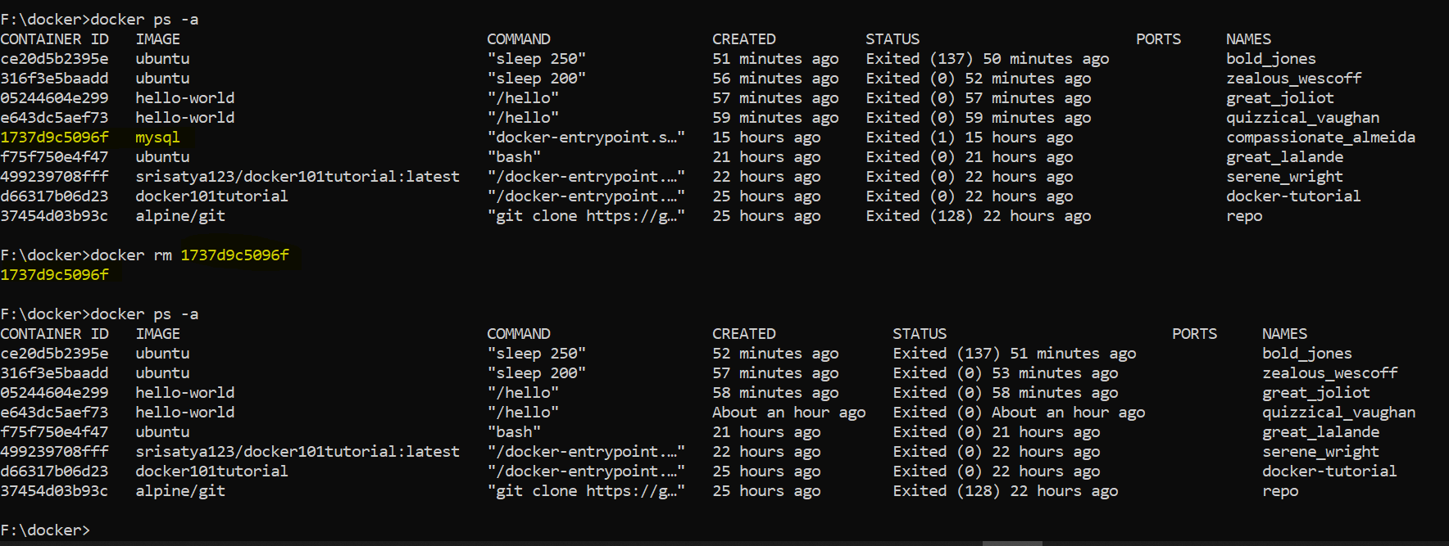

1. **docker rmi <image-id>**

**docker rmi**

This command is used to delete an image from local storage. Before deleting the image first need to delete the associated container.

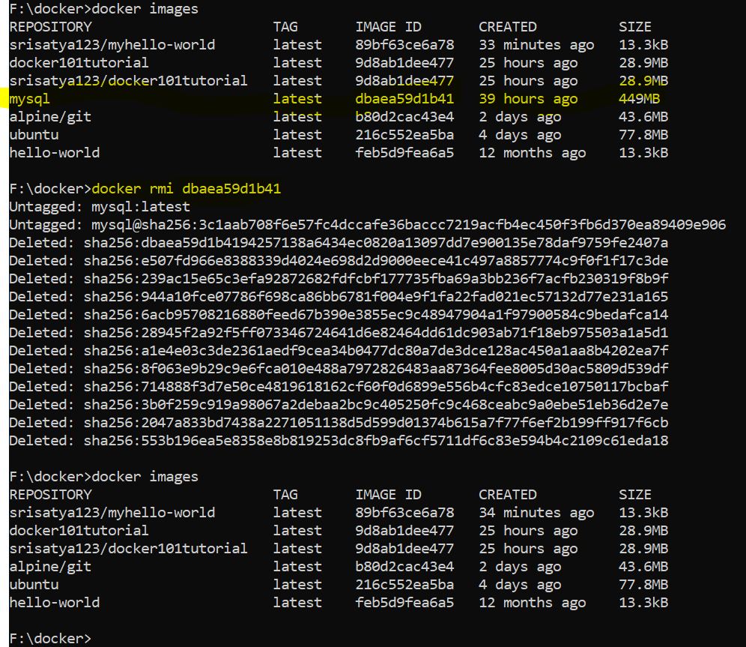

1. **docker inspect container**

**this command is used to display detail info of a container**

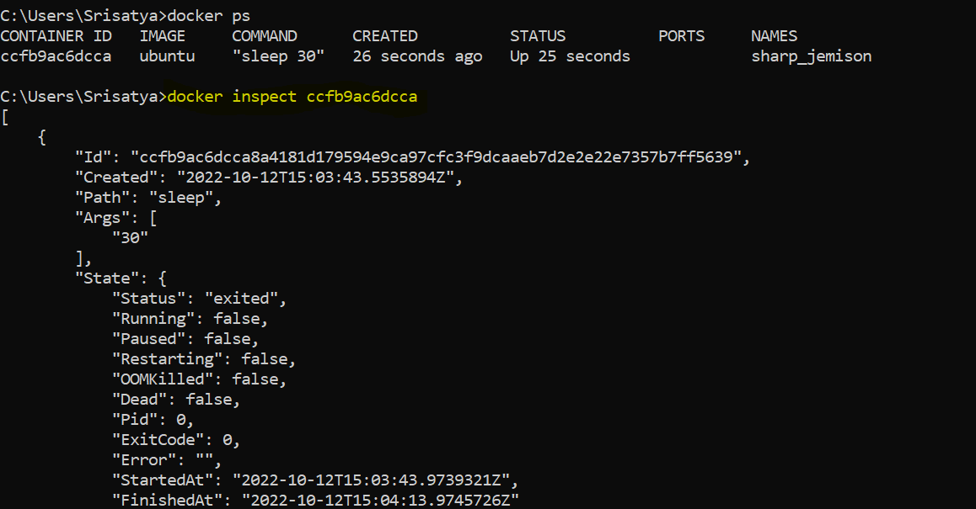

1. **docker logs [options] <container_name>**

This commands shows the log of the container.

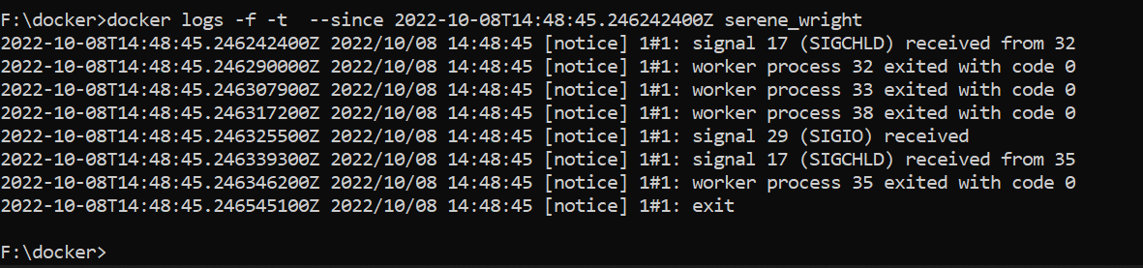

**Assignment 2:**

[Hello World Docker Image](https://hub.docker.com/_/hello-world) Run Hello World Docker Image Locally.



### Assignment 3:

Create a hello world fastapi application. Create a Dockerfile for your fastapi hello world application. Build Docker image using Docker file. Run docker image build in previous step. Push your Docker image to Docker Hub.

Docker file and building image 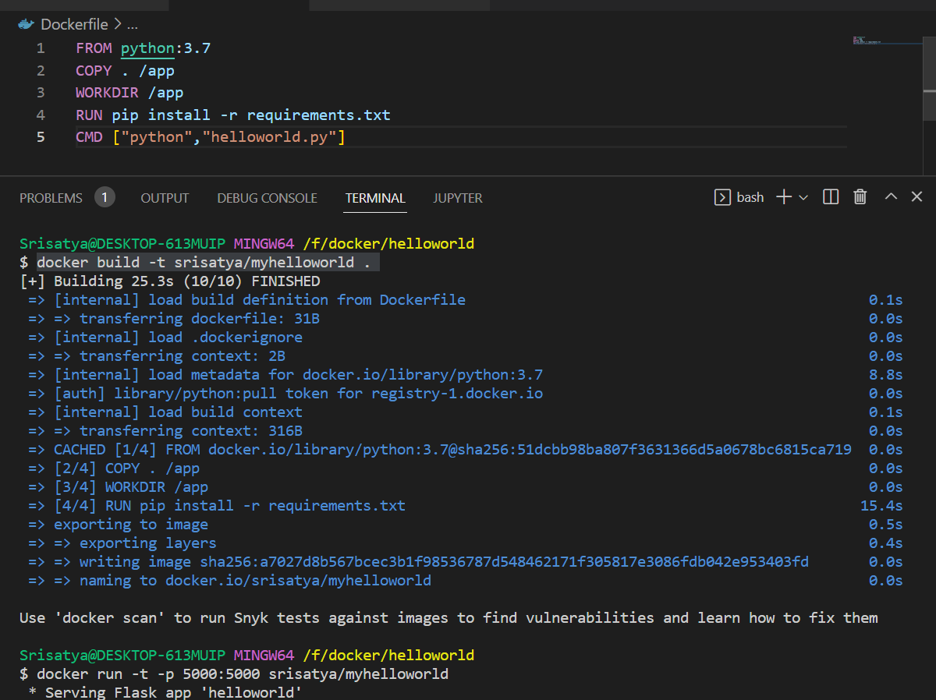

Running docker image

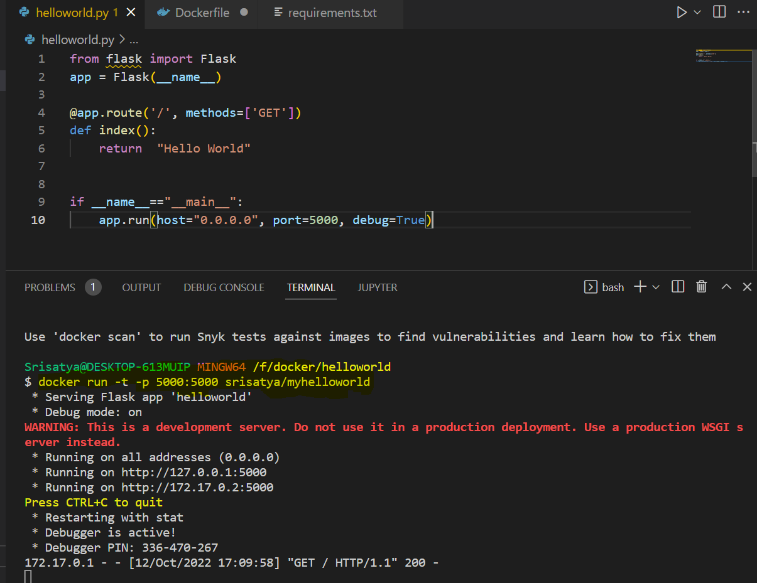

Running docker

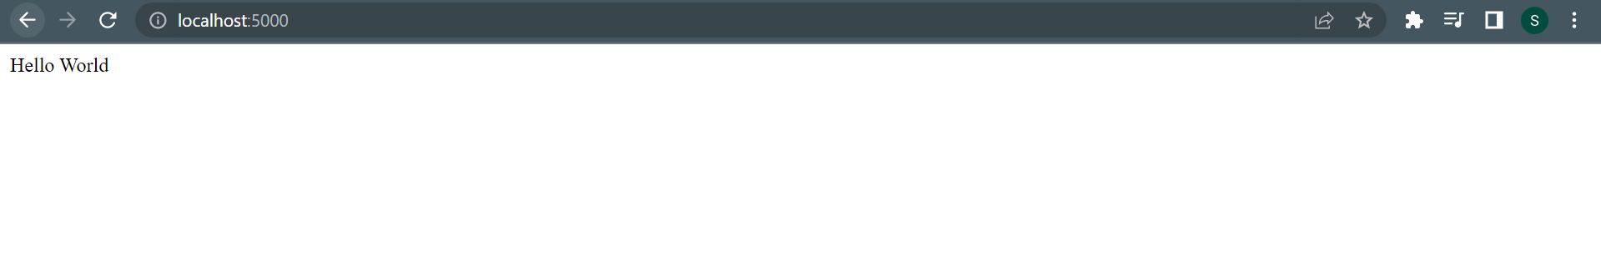

Pushing to Docker Hub:

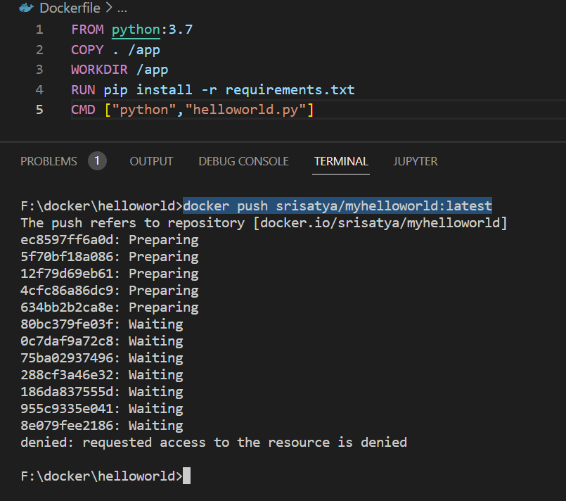

**Assignment 4:**

Automate Assignment below task using github action.

1. Build Docker Image
2. Push Docker Image to Docker hub.

Github repository link : <https://github.com/Srisatya123/Docker-image-autobuild>

Screen shots:

1. Docker file :

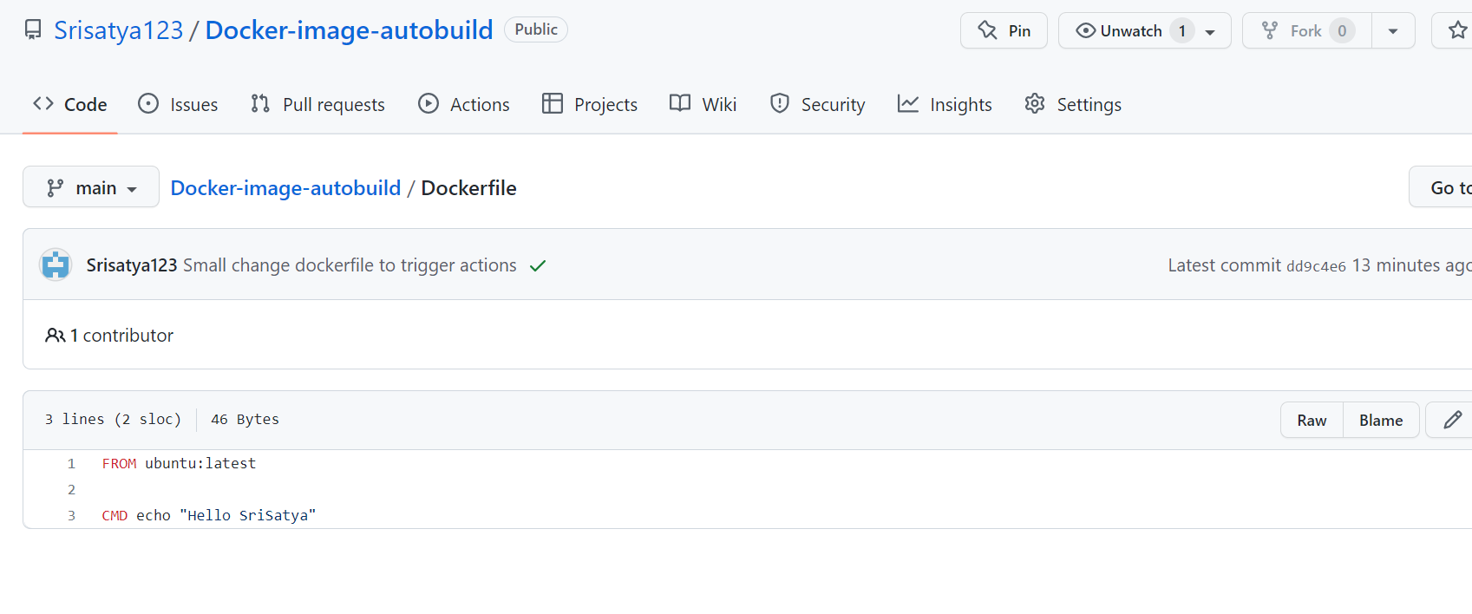

1. Actions file: in this docker secret token added as a github secret token.

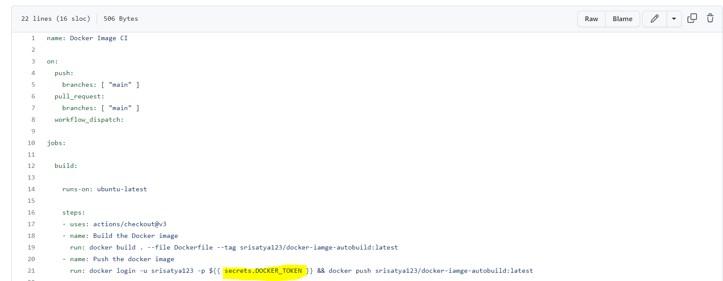

1. Workflow: To run workflow manually added workflow_dispatcher

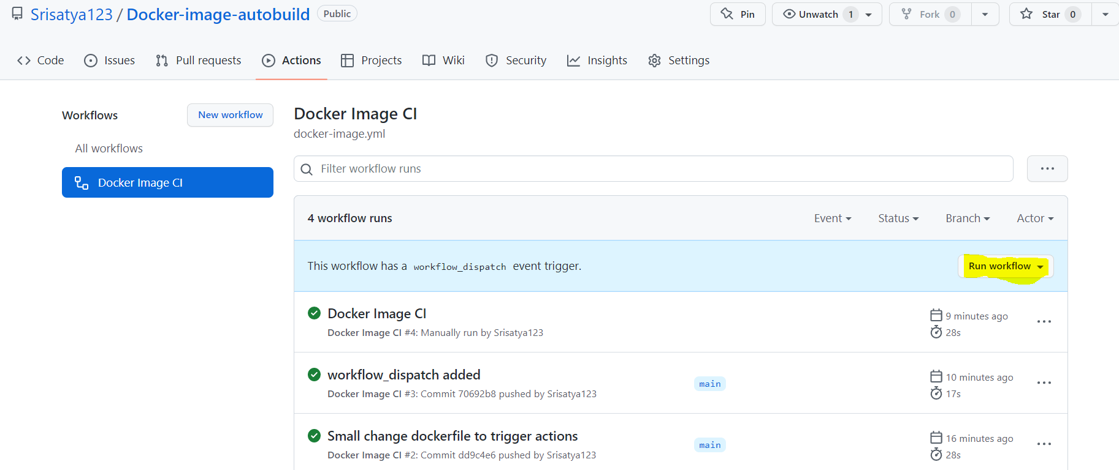

1. docker Repositories from my docker hub:

